THE MILITARY CAREER OF BYRON R. PIPES
Submitted by his son, Arthur Ransdell “Randy” Pipes - 2009
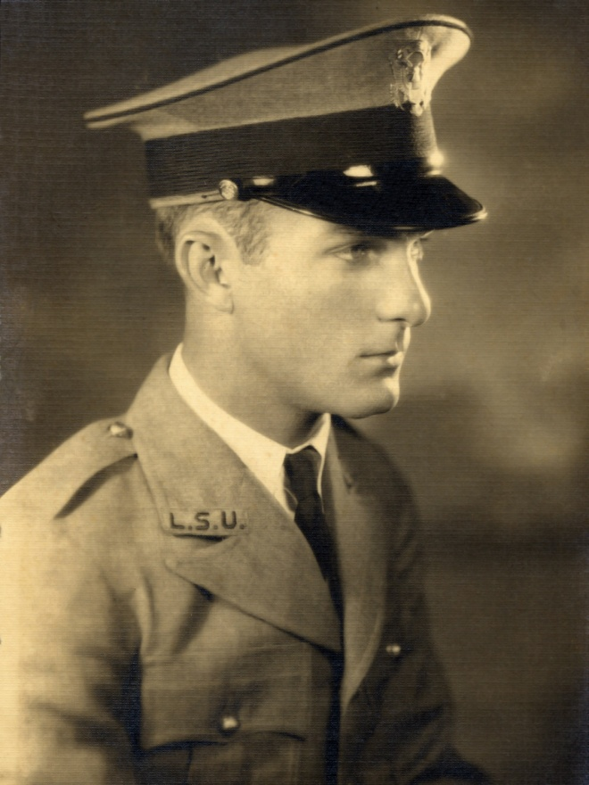
Byron R Pipes in his ROTC uniform at LSU in 1928
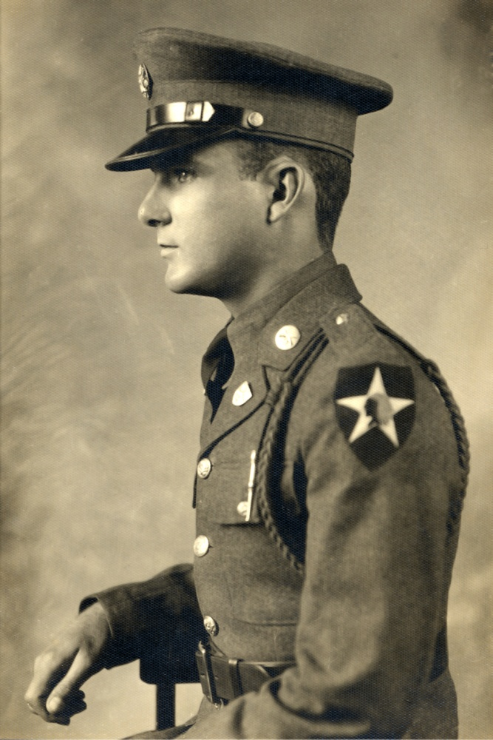
Byron R. Pipes in the US Army at Ft. Sam Houston, 1929.

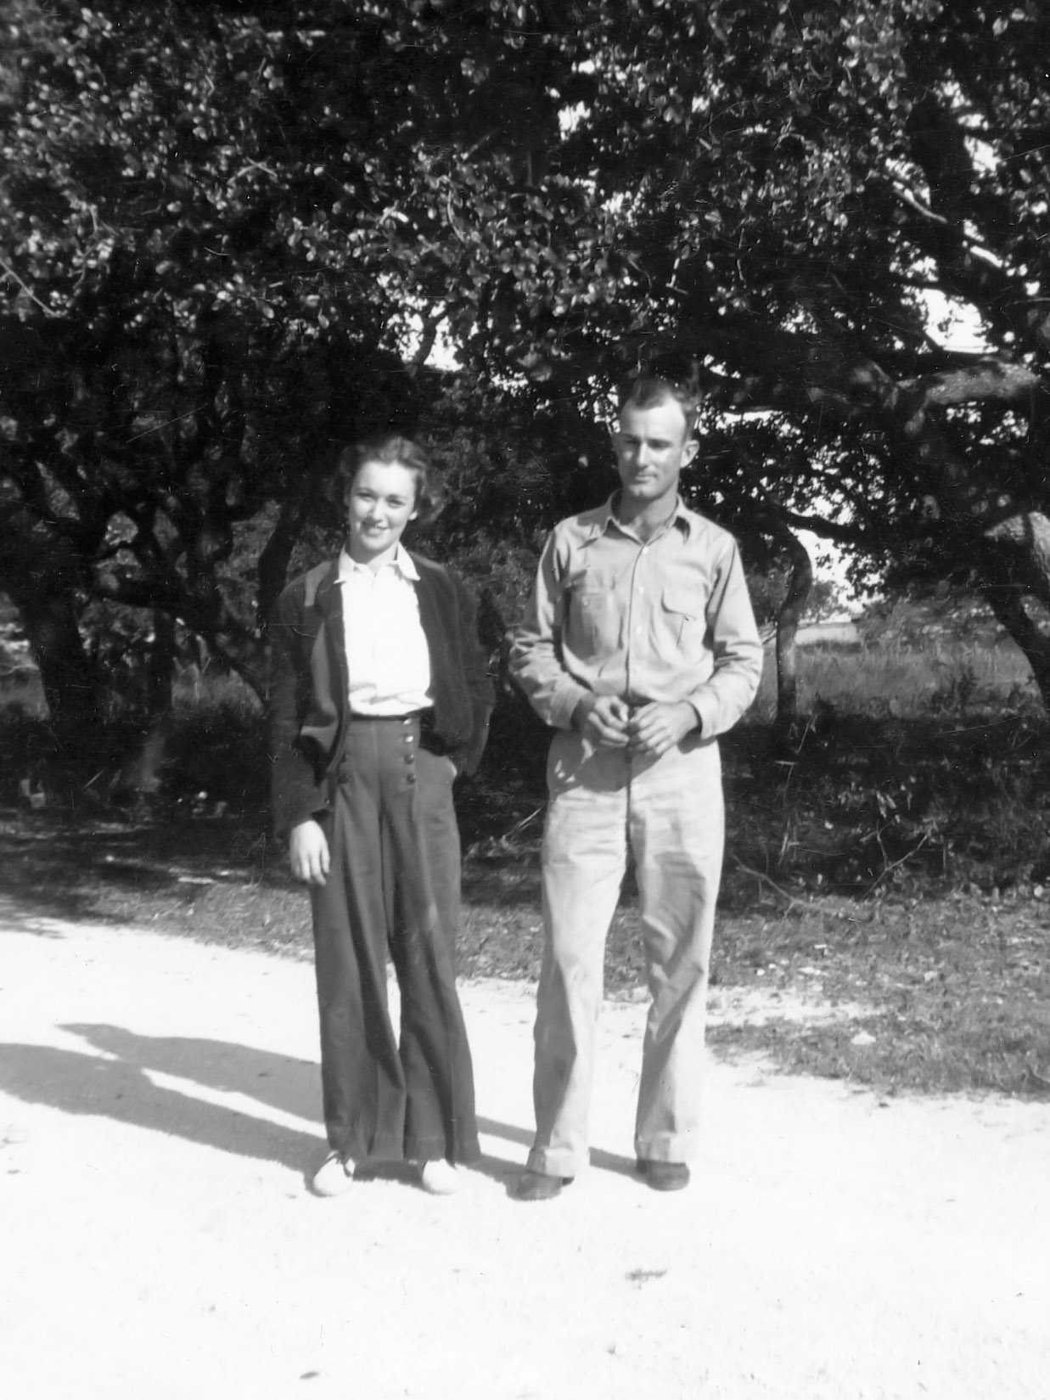
Byron R. Pipes and first wife Elizabeth Batson near Corpus Christi in 1936.
Dad had left the Army and was working in the S. Texas oil fields.
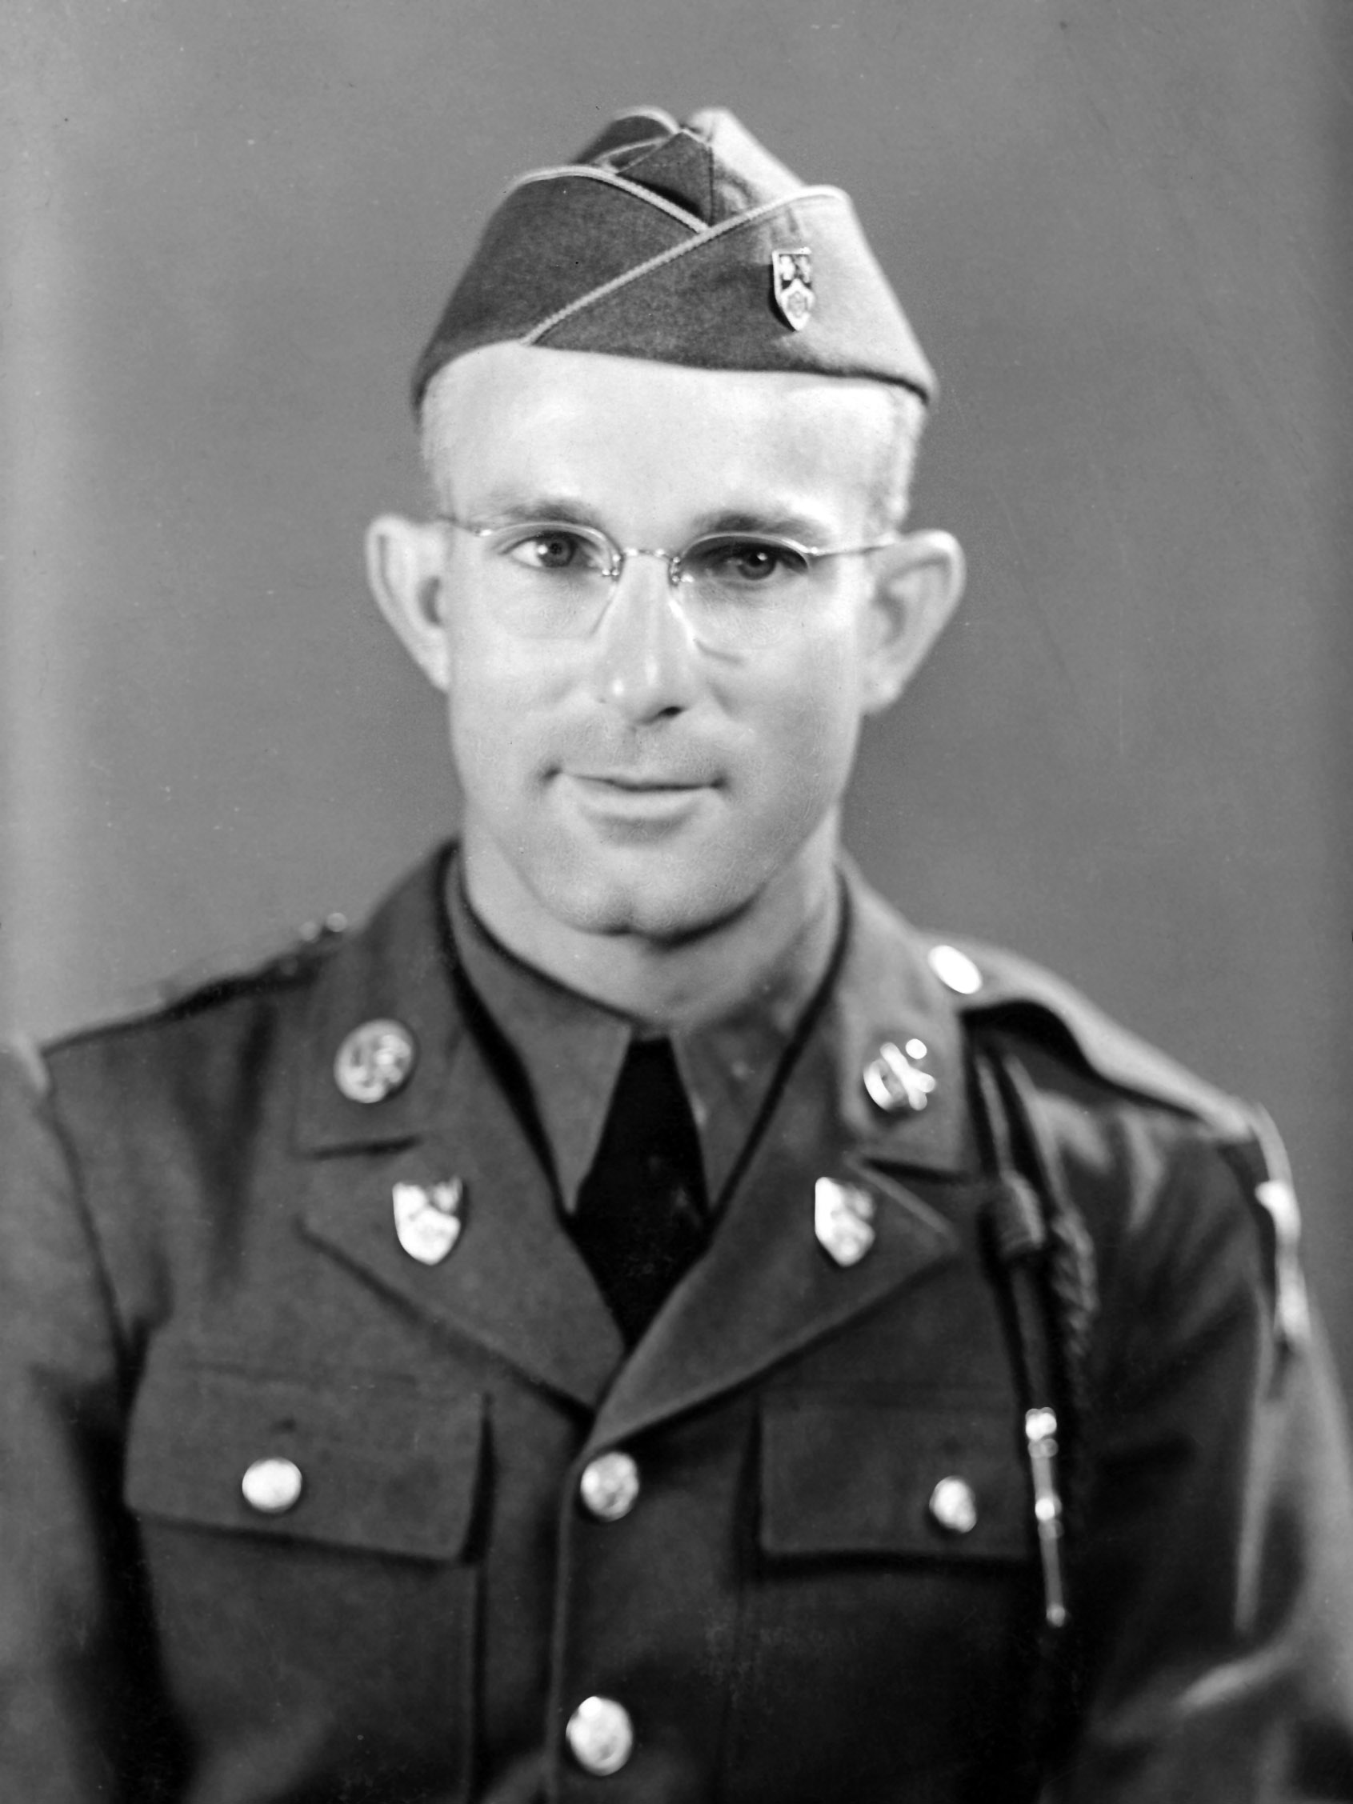
Byron R. Pipes after being recalled to the US Army in 1941.
He rejoined his old unit – 23rd Infantry, 2nd Div.

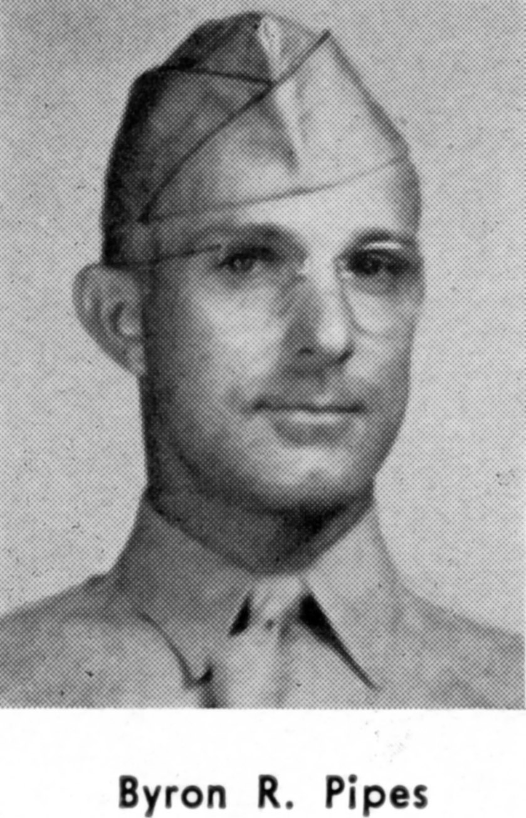
Dad was selected to join the Army Air Force in ’41. Directly afterward he went to Officer Candidate School (OCS) in Miami. This is his picture in the OCS yearbook. He received his commission as a Captain upon graduation.
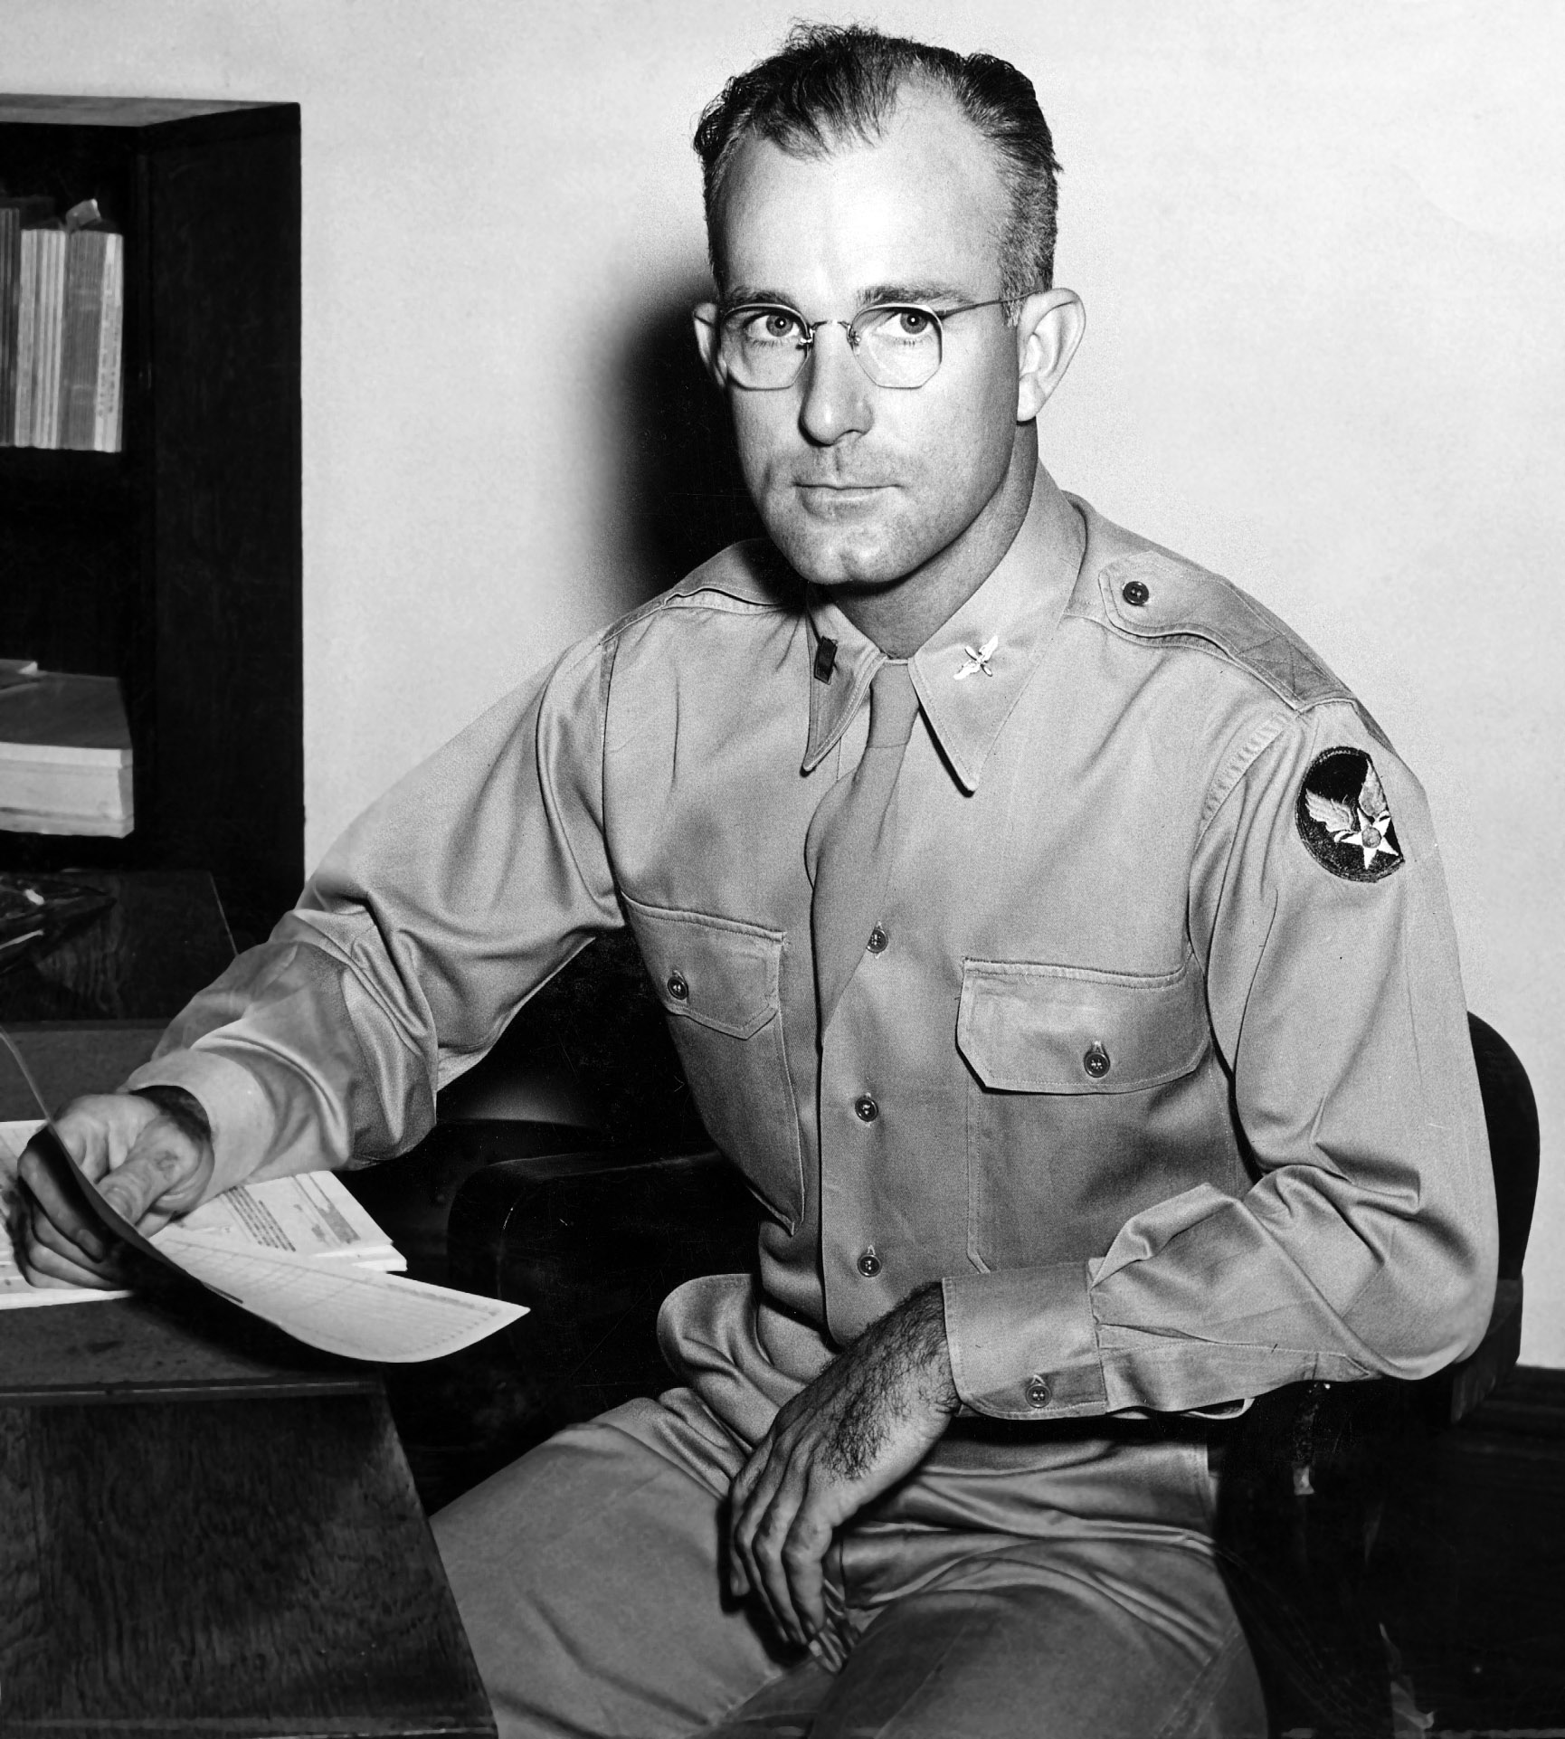
Dad was assigned to the 302nd College Training Detachment (Knox College in Illinois) as a Tactical Training officer in 1943.

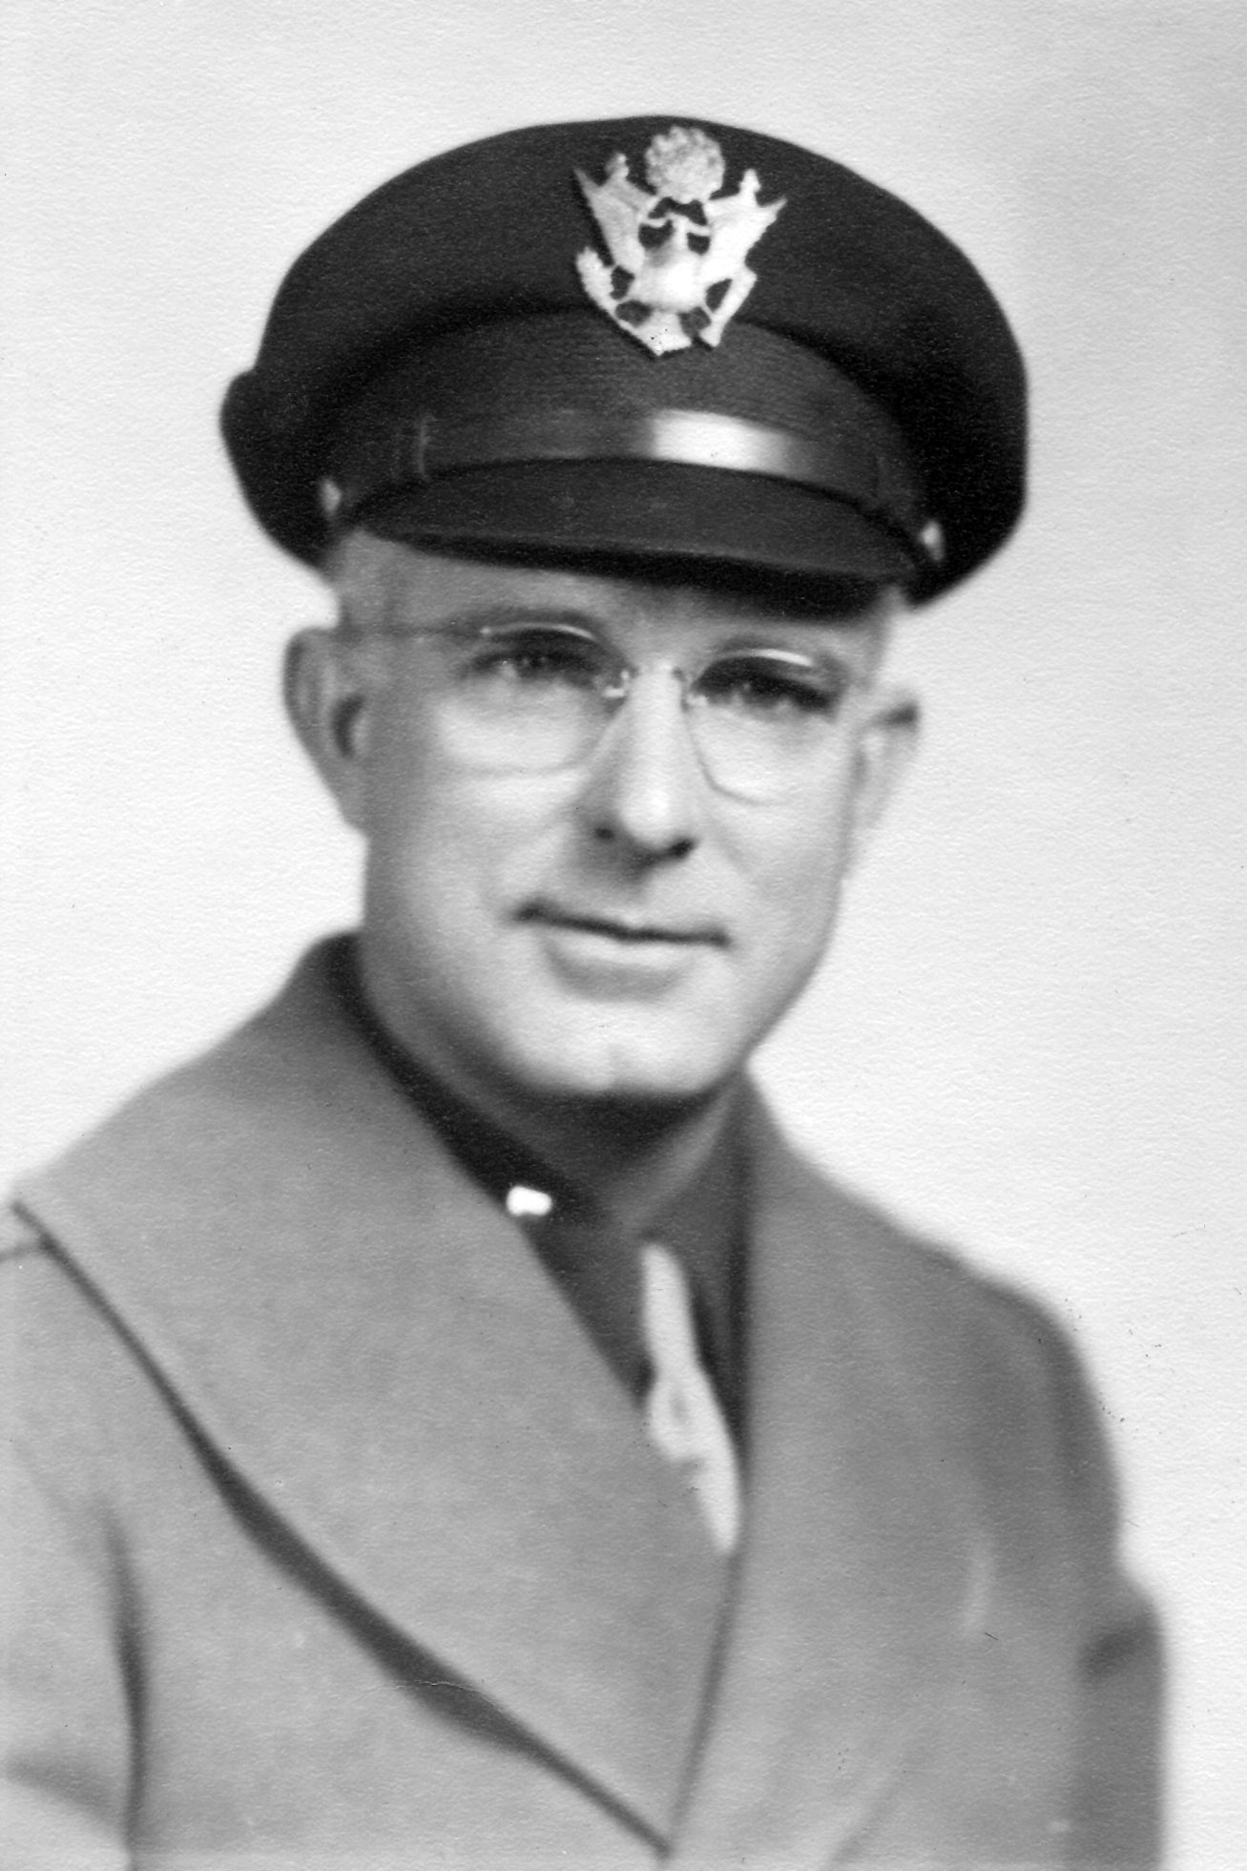
Byron R. Pipes as Training Officer at Knox College in 1943.
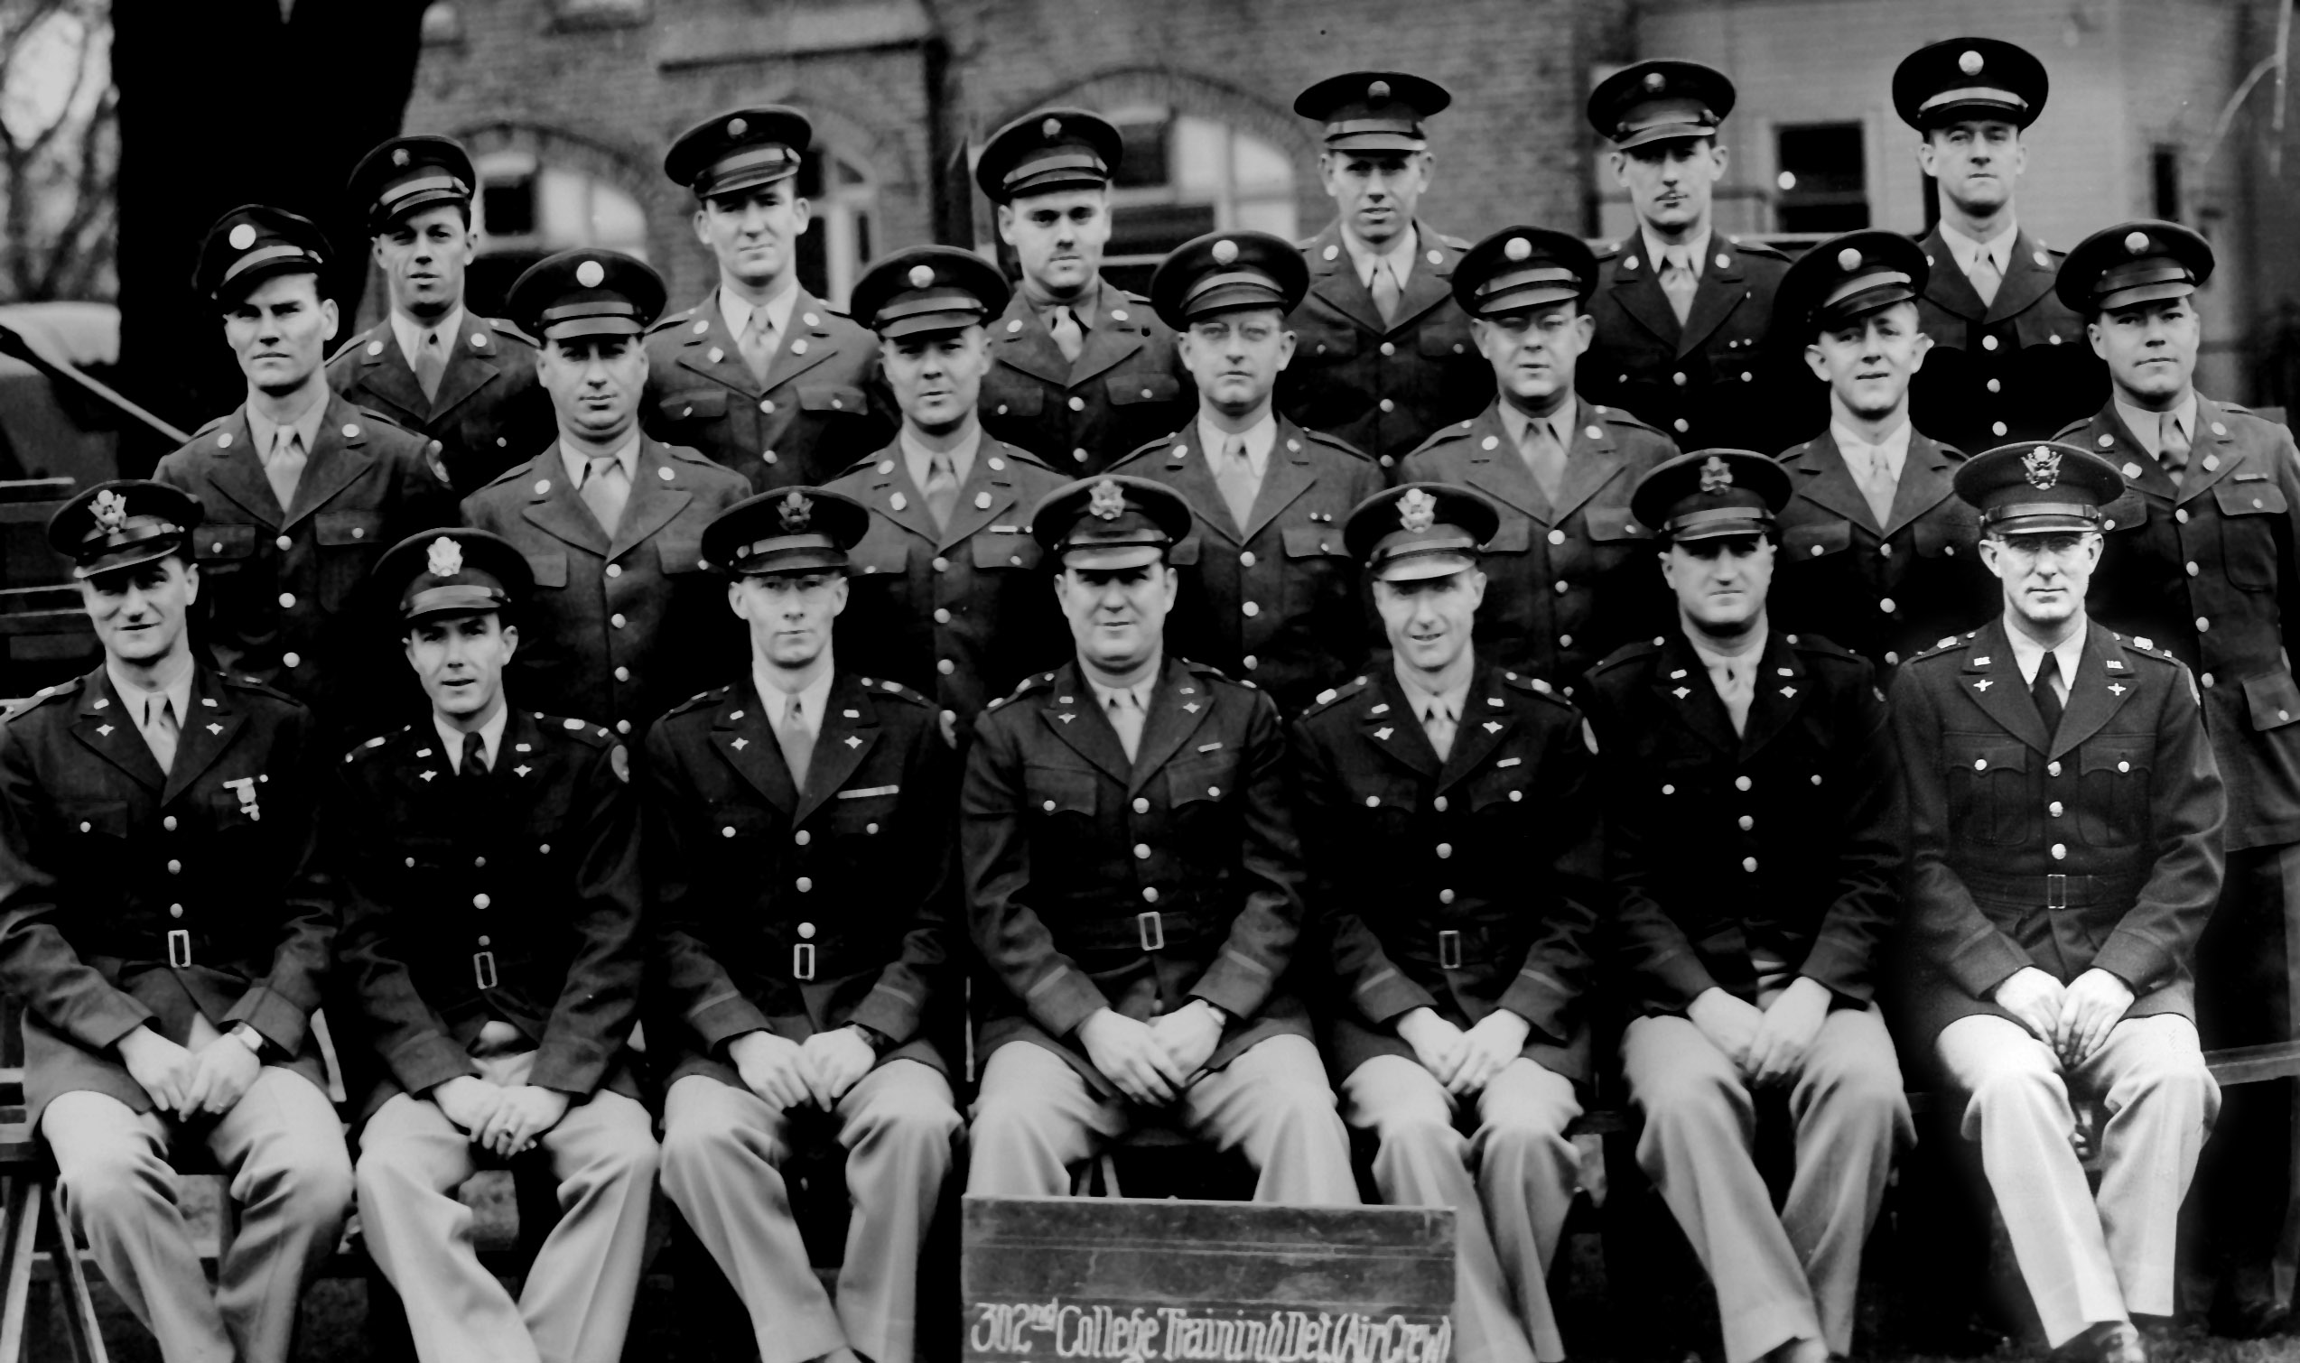
Also at Knox College, Byron R Pipes is front row far right.
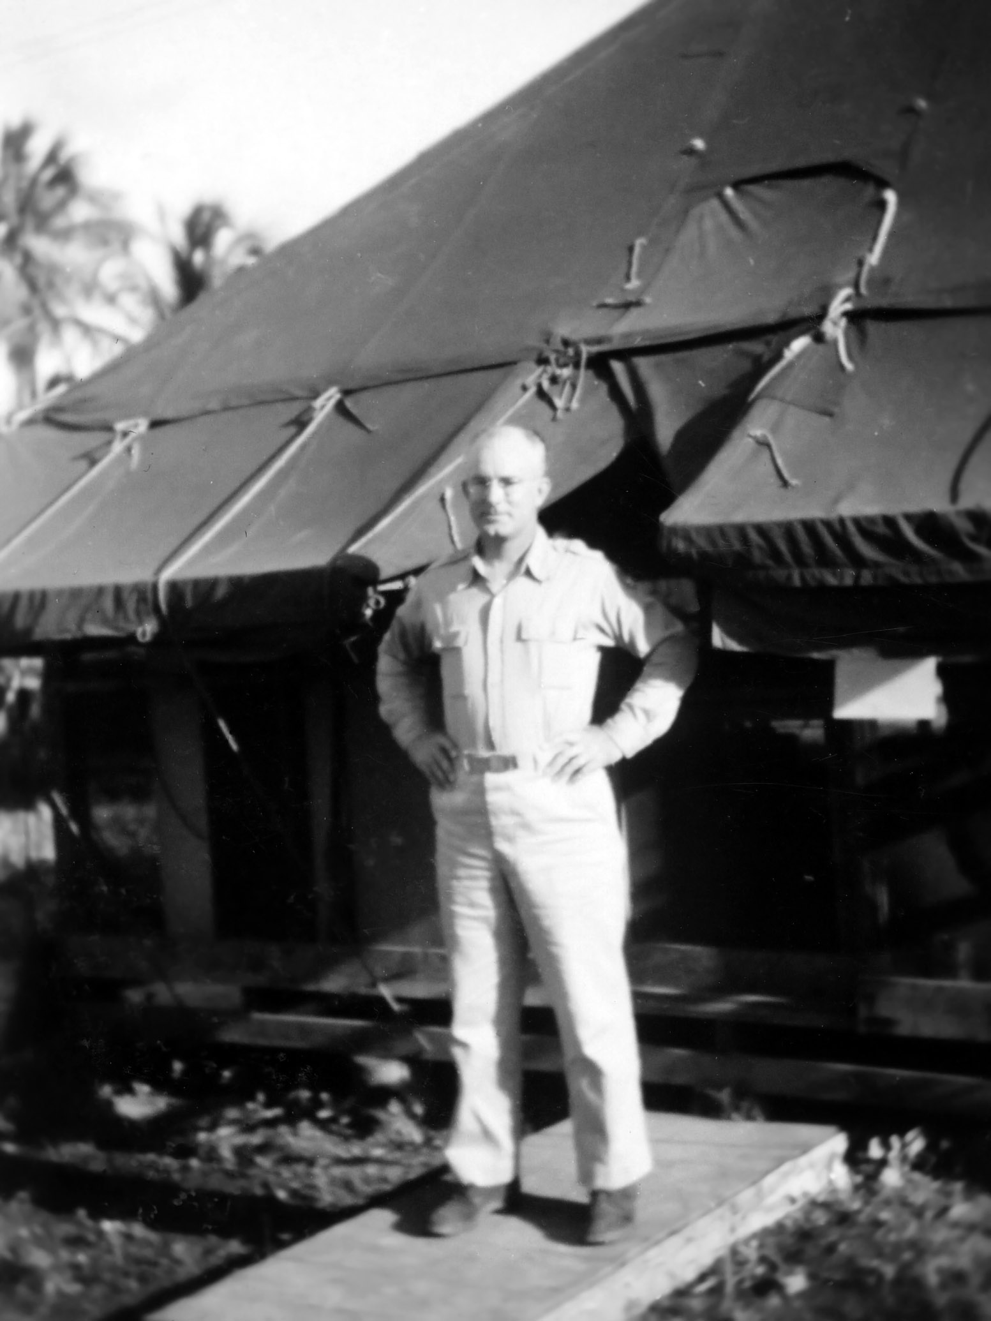
Byron R. Pipes, 1946 in Guam with the 20th Air Force
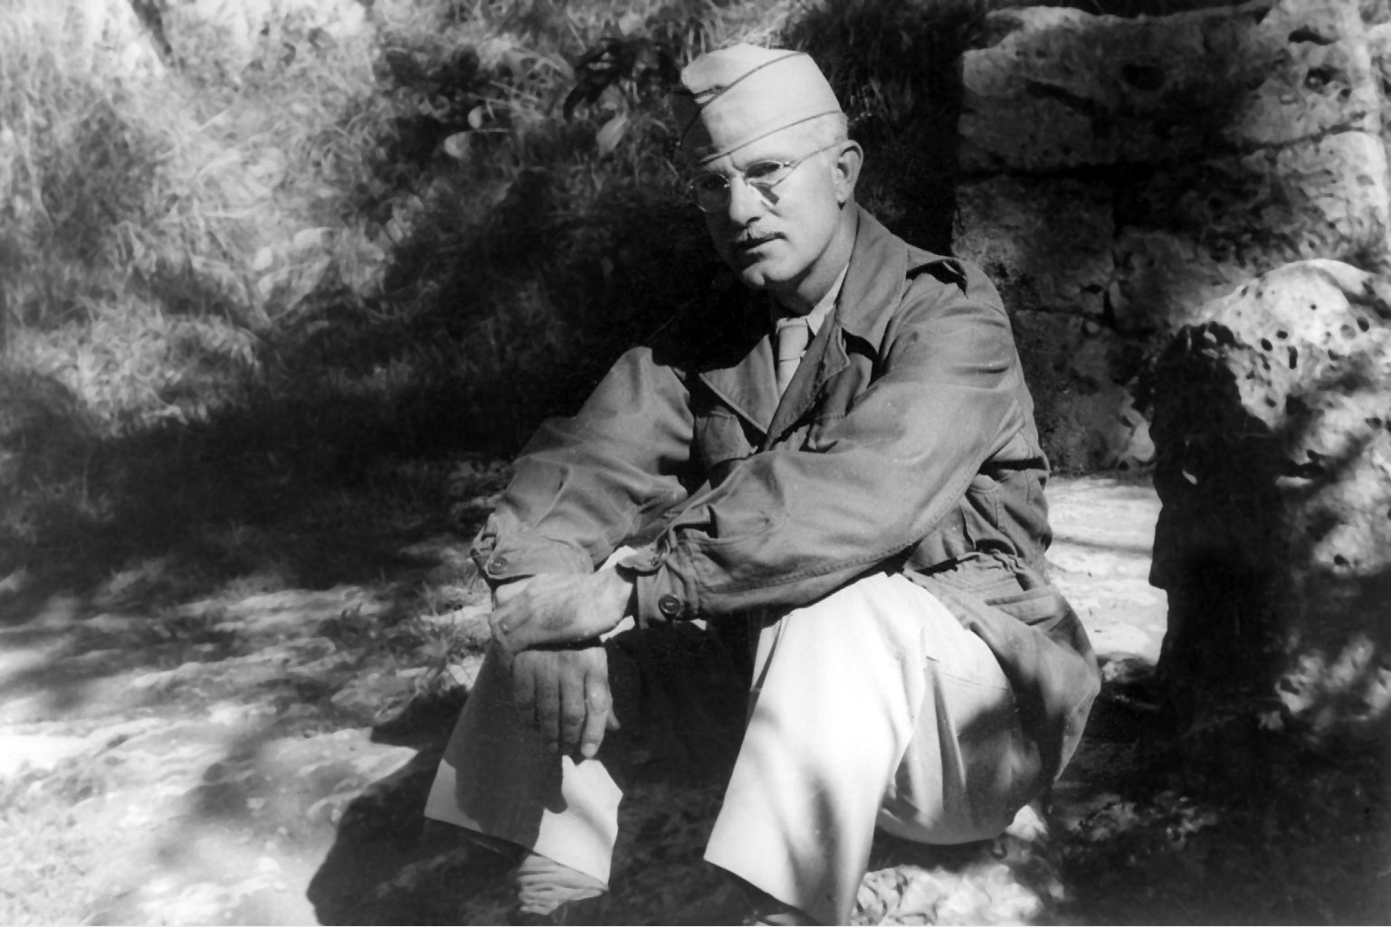
Byron R. Pipes with the 1st Air Division, Okinawa, 1948

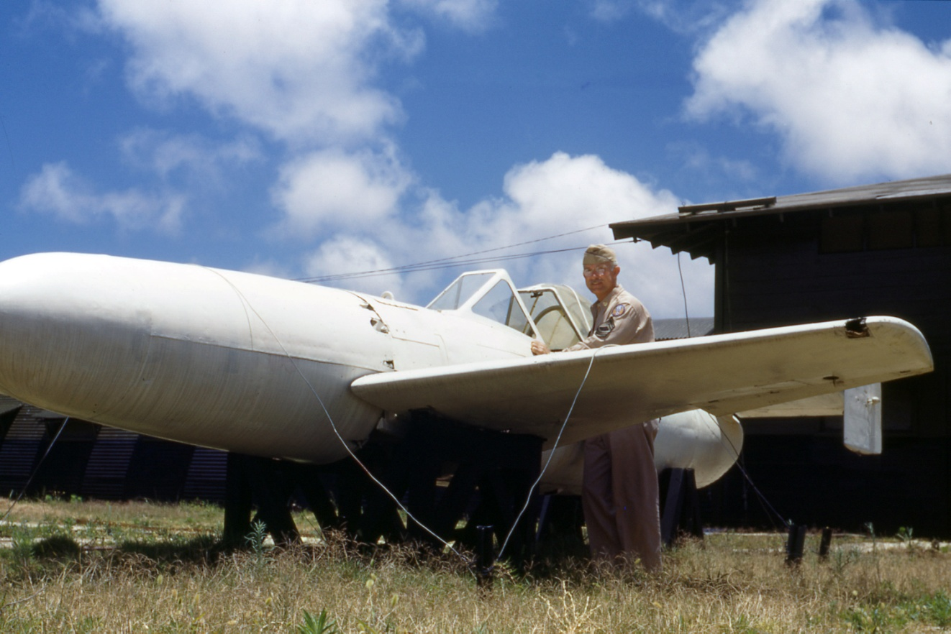
Also in Okinawa, 1948. Dad is posing with a Japanese Ohka human-guided rocket-powered bomb.
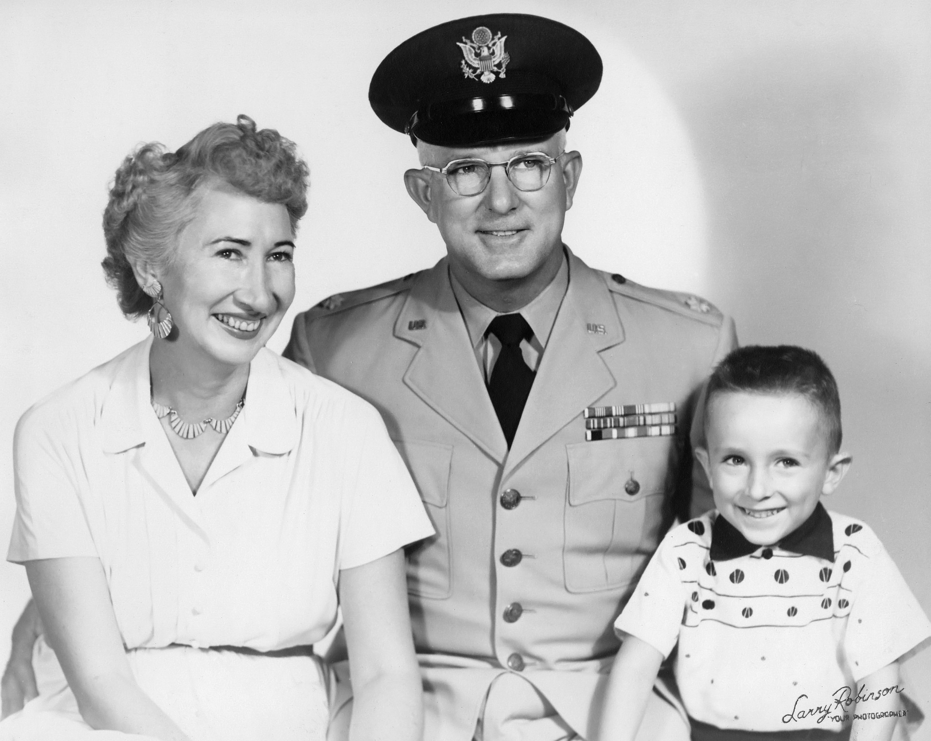
1955 in Laredo, TX: my mother, Grace Dordan Pipes, dad as a USAF Major, and me.

